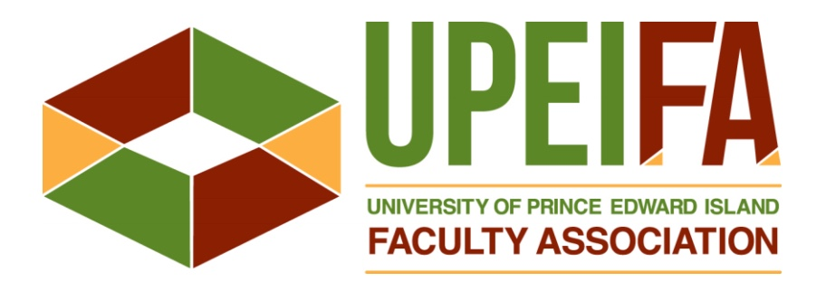
Second Call for
Nominations, 2021-2022
__________________________________________________________________________________
In accordance with the UPEI Faculty Association’s Bylaws (Article 13.11.5), this is a second call for the nomination of individuals for election to various Association positions for 2021-22.
Elections to be held at the Association’s Annual General Meeting
Friday, April 23, 2021
See Bylaw Article 13 for the procedures for nominations and elections and
the attached summary of key dates and deadlines for the nomination process.
____________________________________________________________________________________
There were fewer nominations received in response to the initial call than vacancies available. Consequently, this a second call for nominations to the following Committees:

- Communications Committee – Member (one position, two-year term)
- Research and Advocacy Committee – Members (four positions, all two-year terms)
- Equity Committee – Members (three positions, all two-year terms)
____________________________________________________________________________________
Nominations must be received by the Chair of the Nominating Committee
no later than Monday, April 5, 2021.
- Individuals admitted to the Association’s Membership in accordance with Bylaw Article 4.3 are eligible to be nominated. Those elected must be Members for the entire term of office.
- Nominations must be made in writing using the attached nomination form and be accompanied by confirmation from the nominee that s/he is willing to serve in the position.
- No nominations will be accepted at the meeting.
See Bylaw Article 13.11 for full details of the nomination procedure.
All questions and nominations should be directed to the Nominating Committee Chair.
Jessica V Strong – (e) jvstrong@upei.ca / (t) 894-2889 / Memorial Hall 215
____________________________________________________________________________________The Nominating Committee shall make every effort to ensure that the Executive Committee and all Standing Committees reflect the diversity of the Association’s membership in so far as possible in respect to employment category, discipline and recognized equity groups. [Bylaw Article 12.8(g)]

Nomination Process – Key Dates and Deadlines

Friday, March 12, 2021
- Initial call for nominations issued to the membership.

Monday, March 22, 2021
- Deadline for receipt of nominations in response to the initial call.

Friday, March 26, 2021
- Notice of nominees received in response to initial call, issued to the membership.
- Second call for nominations issued to the membership for only those positions which receive fewer nominations in response to the initial call than there are vacancies for the position.

Monday, April 5, 2021
- Deadline for receipt of nominations in response to the second call.

Friday, April 16, 2021 (at least one week prior to the AGM)
- Notice, indicating the final slate of nominees received, issued to the membership.

